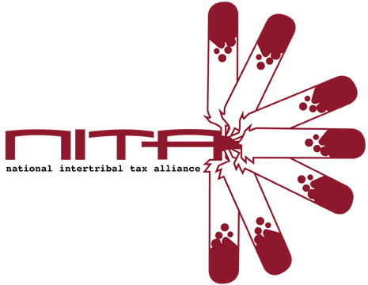
NatioNal INtertribal Tax AlliaNce
2025 Tribal Tax Conference Registration
October 6-8, 2026
Chinook Winds Resort, Lincoln City Oregon

Full Name: Title: Tribe/Company: Street Address:

City: , State: ZIP: Phone Number: Email:

Total Number of Attendees (Please complete a registration form for each attendee.)
Shirt Size for the gift from the NITA Board of Directors: _______
Small/Medium/Large/XL/XXL/3XL
Are you a Conference Speaker?:
Yes/No
(Note: Registration fees are waived for conference speakers.)
Are you a vendor? Y__ N___ How many tables do you need? _____
Yes/No
Vendor Registration Fee: $150.00 total for both days

Conference Registration Rates:
$700.00 for one person, or
$675.00/person for two or more attendees from the same Tribe/Organization
Student registration: $300.00/person. Must specify University:

Conference Registration Total: $_______________ Check#: ____________
Signed: Date:
Please make checks payable to Intertribal Tax Alliance Inc. C/O Mary Mashunkashey
Mail check to: 1714 E. 60th St., Tulsa, OK 74105 Return form by email to: nitacoord@gmail.com CC#: Exp: CVC:

Reserve Your Room at the Chinook Winds Resort before September 6, 2026. Call: 1-888- 244-6665 and Use Group Code: NITA
Rate: $159.00/night; Rate for Double Queen or King, $114.00/nigh: Rate for Compact Single bed room.
NO SHUTTLE TO RESORT

